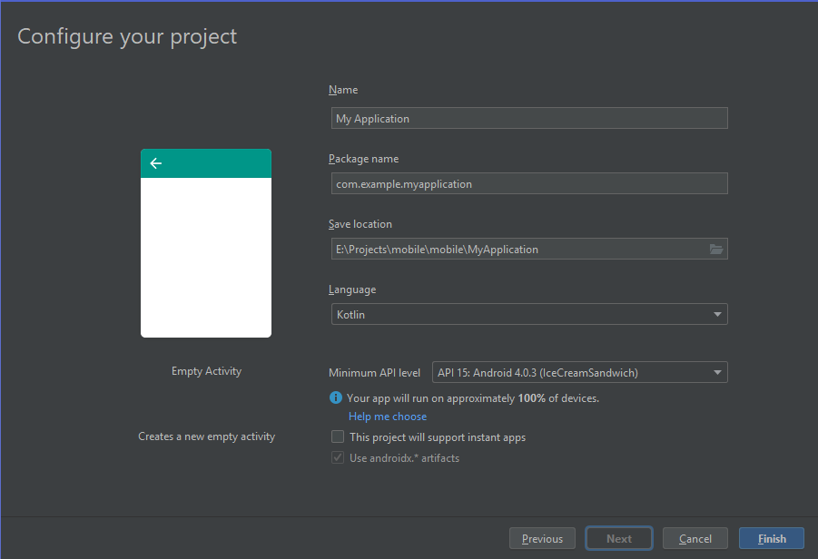

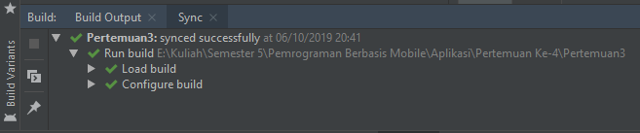

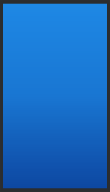

|  |
| --- |
| <?xml version="1.0" encoding="utf-8"?>  <selector xmlns:android="http://schemas.android.com/apk/res/android">  <item>  <shape>  <gradient  android:startColor="#0D47A1"  android:centerColor="#1976D2"  android:endColor="#1E88E5"  android:angle="90"></gradient>  </shape>  </item>  </selector> |

|  |
| --- |
| <?xml version="1.0" encoding="utf-8"?>  <selector xmlns:android="http://schemas.android.com/apk/res/android">  <item>  <color  android:color="#BBDEFB"  ></color>  </item>  </selector> |

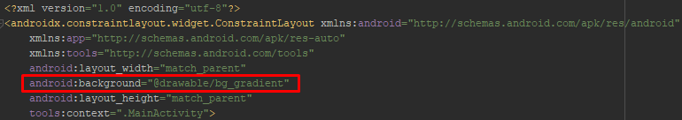

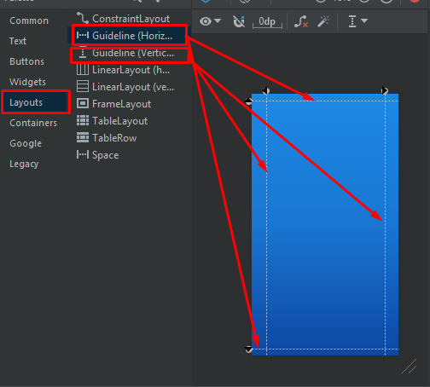

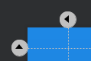

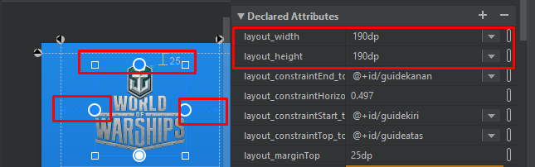

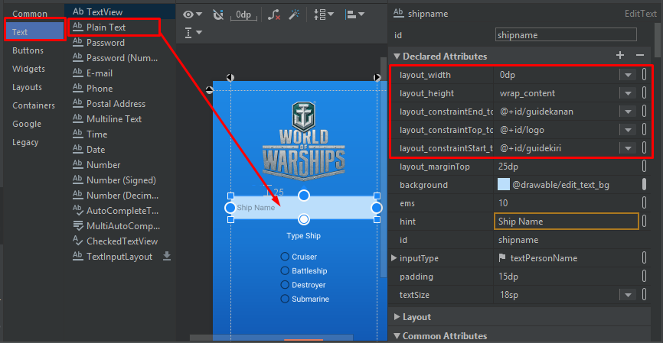

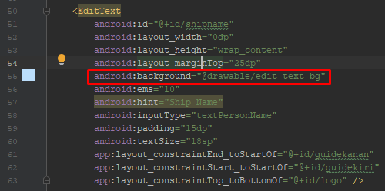

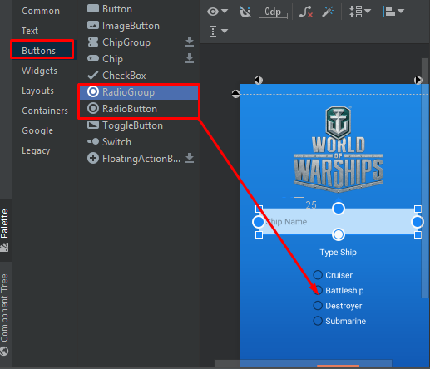

|  |
| --- |
| <RadioGroup  android:id="@+id/grouptype"  android:layout_width="wrap_content"  android:layout_height="wrap_content"  android:layout_marginTop="20dp"  app:layout_constraintEnd_toStartOf="@+id/guidekanan"  app:layout_constraintStart_toStartOf="@+id/guidekiri"  app:layout_constraintTop_toBottomOf="@+id/textView">  <RadioButton  android:id="@+id/cruiser"  android:layout_width="match_parent"  android:layout_height="wrap_content"  android:text="Cruiser"  android:textColor="#FFFFFF"  android:textColorLink="#FFFFFF"  android:textSize="18sp"  tools:layout_editor_absoluteX="201dp"  tools:layout_editor_absoluteY="455dp" />  <RadioButton  android:id="@+id/battleship"  android:layout_width="match_parent"  android:layout_height="wrap_content"  android:text="Battleship"  android:textColor="#FFFFFF"  android:textColorLink="#FFFFFF"  android:textSize="18sp"  tools:layout_editor_absoluteX="201dp"  tools:layout_editor_absoluteY="455dp" />  <RadioButton  android:id="@+id/destroyer"  android:layout_width="match_parent"  android:layout_height="wrap_content"  android:text="Destroyer"  android:textColor="#FFFFFF"  android:textColorLink="#FFFFFF"  android:textCursorDrawable="@android:color/holo_orange_light"  android:textSize="18sp"  tools:layout_editor_absoluteX="201dp"  tools:layout_editor_absoluteY="455dp" />  <RadioButton  android:id="@+id/submarine"  android:layout_width="match_parent"  android:layout_height="wrap_content"  android:text="Submarine"  android:textColor="#FFFFFF"  android:textColorLink="#FFFFFF"  android:textSize="18sp"  tools:layout_editor_absoluteX="201dp"  tools:layout_editor_absoluteY="455dp" />  </RadioGroup> |

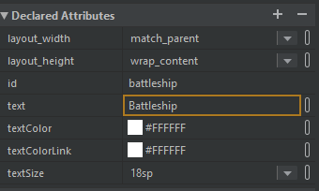

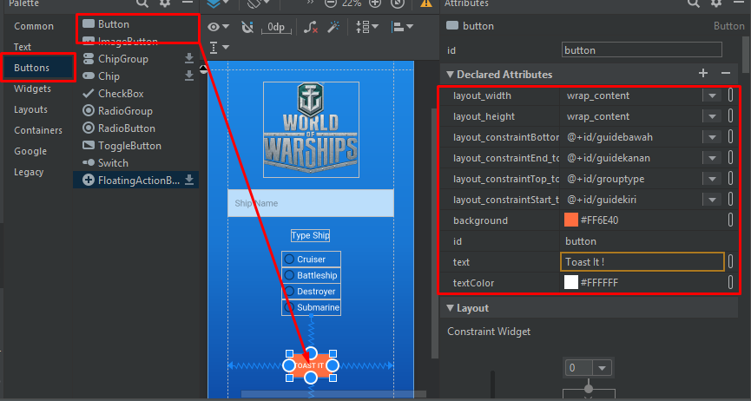



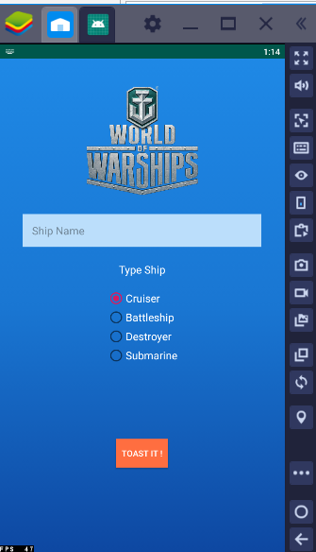

|  |
| --- |
| <?xml version="1.0" encoding="utf-8"?>  <androidx.constraintlayout.widget.ConstraintLayout xmlns:android="http://schemas.android.com/apk/res/android"  xmlns:app="http://schemas.android.com/apk/res-auto"  xmlns:tools="http://schemas.android.com/tools"  android:layout_width="match_parent"  android:background="@drawable/bg_gradient"  android:layout_height="match_parent"  tools:context=".MainActivity">  <androidx.constraintlayout.widget.Guideline  android:id="@+id/guidekiri"  android:layout_width="wrap_content"  android:layout_height="wrap_content"  android:orientation="vertical"  app:layout_constraintGuide_begin="40dp" />  <androidx.constraintlayout.widget.Guideline  android:id="@+id/guidekanan"  android:layout_width="wrap_content"  android:layout_height="wrap_content"  android:orientation="vertical"  app:layout_constraintGuide_end="40dp" />  <androidx.constraintlayout.widget.Guideline  android:id="@+id/guideatas"  android:layout_width="wrap_content"  android:layout_height="wrap_content"  android:orientation="horizontal"  app:layout_constraintGuide_begin="20dp" />  <androidx.constraintlayout.widget.Guideline  android:id="@+id/guidebawah"  android:layout_width="wrap_content"  android:layout_height="wrap_content"  android:orientation="horizontal"  app:layout_constraintGuide_end="20dp" />  <ImageView  android:id="@+id/logo"  android:layout_width="190dp"  android:layout_height="190dp"  android:layout_marginTop="25dp"  android:contentDescription="TODO"  app:layout_constraintEnd_toStartOf="@+id/guidekanan"  app:layout_constraintHorizontal_bias="0.497"  app:layout_constraintStart_toStartOf="@+id/guidekiri"  app:layout_constraintTop_toTopOf="@+id/guideatas"  app:srcCompat="@drawable/logo" />  <EditText  android:id="@+id/shipname"  android:layout_width="0dp"  android:layout_height="wrap_content"  android:layout_marginTop="25dp"  android:background="@drawable/edit_text_bg"  android:ems="10"  android:hint="Ship Name"  android:inputType="textPersonName"  android:padding="15dp"  android:textSize="18sp"  app:layout_constraintEnd_toStartOf="@+id/guidekanan"  app:layout_constraintStart_toStartOf="@+id/guidekiri"  app:layout_constraintTop_toBottomOf="@+id/logo" />  <TextView  android:id="@+id/textView"  android:layout_width="wrap_content"  android:layout_height="wrap_content"  android:layout_marginTop="25dp"  android:text="Type Ship"  android:textColor="#FFFFFF"  android:textSize="18sp"  app:layout_constraintEnd_toStartOf="@+id/guidekanan"  app:layout_constraintStart_toStartOf="@+id/guidekiri"  app:layout_constraintTop_toBottomOf="@+id/shipname" />  <RadioGroup  android:id="@+id/grouptype"  android:layout_width="wrap_content"  android:layout_height="wrap_content"  android:layout_marginTop="20dp"  app:layout_constraintEnd_toStartOf="@+id/guidekanan"  app:layout_constraintStart_toStartOf="@+id/guidekiri"  app:layout_constraintTop_toBottomOf="@+id/textView">  <RadioButton  android:id="@+id/cruiser"  android:layout_width="match_parent"  android:layout_height="wrap_content"  android:text="Cruiser"  android:textColor="#FFFFFF"  android:textColorLink="#FFFFFF"  android:textSize="18sp"  tools:layout_editor_absoluteX="201dp"  tools:layout_editor_absoluteY="455dp" />  <RadioButton  android:id="@+id/battleship"  android:layout_width="match_parent"  android:layout_height="wrap_content"  android:text="Battleship"  android:textColor="#FFFFFF"  android:textColorLink="#FFFFFF"  android:textSize="18sp"  tools:layout_editor_absoluteX="201dp"  tools:layout_editor_absoluteY="455dp" />  <RadioButton  android:id="@+id/destroyer"  android:layout_width="match_parent"  android:layout_height="wrap_content"  android:text="Destroyer"  android:textColor="#FFFFFF"  android:textColorLink="#FFFFFF"  android:textCursorDrawable="@android:color/holo_orange_light"  android:textSize="18sp"  tools:layout_editor_absoluteX="201dp"  tools:layout_editor_absoluteY="455dp" />  <RadioButton  android:id="@+id/submarine"  android:layout_width="match_parent"  android:layout_height="wrap_content"  android:text="Submarine"  android:textColor="#FFFFFF"  android:textColorLink="#FFFFFF"  android:textSize="18sp"  tools:layout_editor_absoluteX="201dp"  tools:layout_editor_absoluteY="455dp" />  </RadioGroup>  <Button  android:id="@+id/button"  android:layout_width="wrap_content"  android:layout_height="wrap_content"  android:background="#FF6E40"  android:text="Toast It !"  android:textColor="#FFFFFF"  app:layout_constraintBottom_toTopOf="@+id/guidebawah"  app:layout_constraintEnd_toStartOf="@+id/guidekanan"  app:layout_constraintStart_toStartOf="@+id/guidekiri"  app:layout_constraintTop_toBottomOf="@+id/grouptype" />  </androidx.constraintlayout.widget.ConstraintLayout> |